Azure Data Factory

Week 5 start date: 10-12-2024

**Topics:**

1. **ADF features**
2. ADF workspace setup
3. ADF launch
4. Creating pipeline
5. Linking it with databricks or other accounts.

**Reference:**

Useful resource: youtube Databag channel

**ADF features:**

1. Pipelines: to group the activities
2. Activities: refer screenshot 2 in pipeline topic below.
3. Create Data set
4. Integration runtime (ADF have compute – cluster creation as well)
5. Triggers – example daily at 9AM you want to do a task.

**ADF workspace setup:**

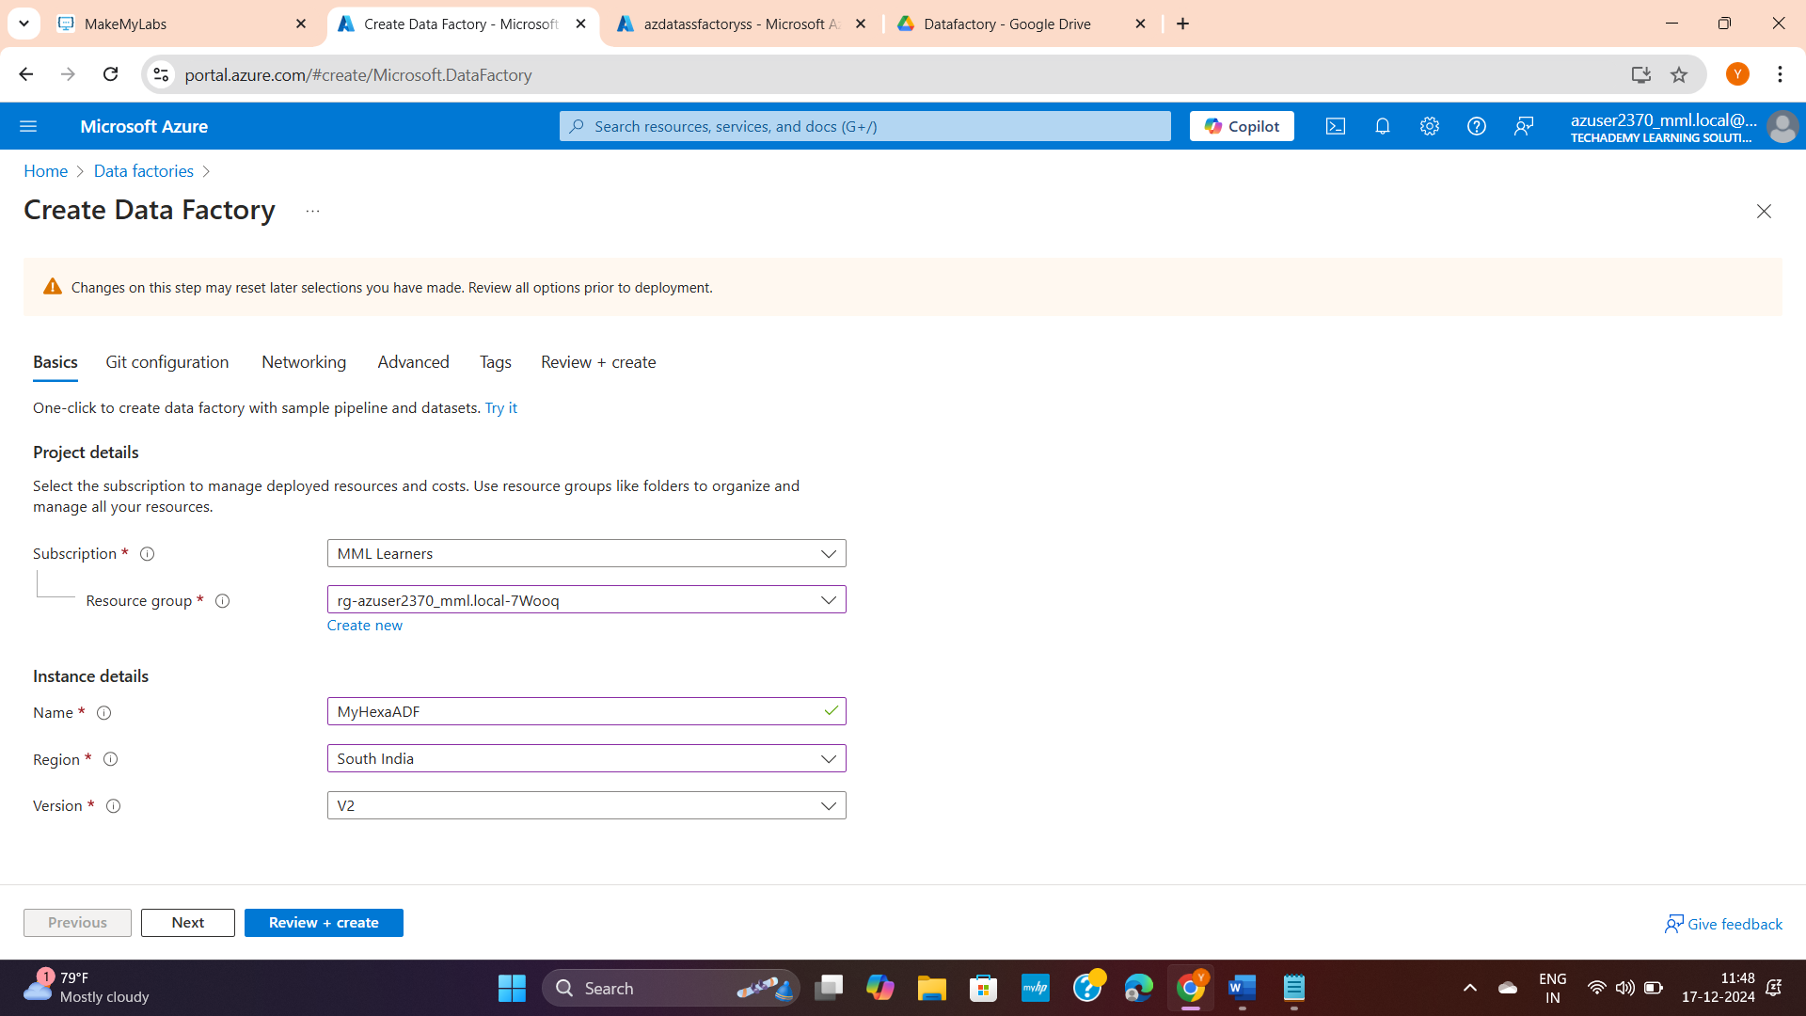

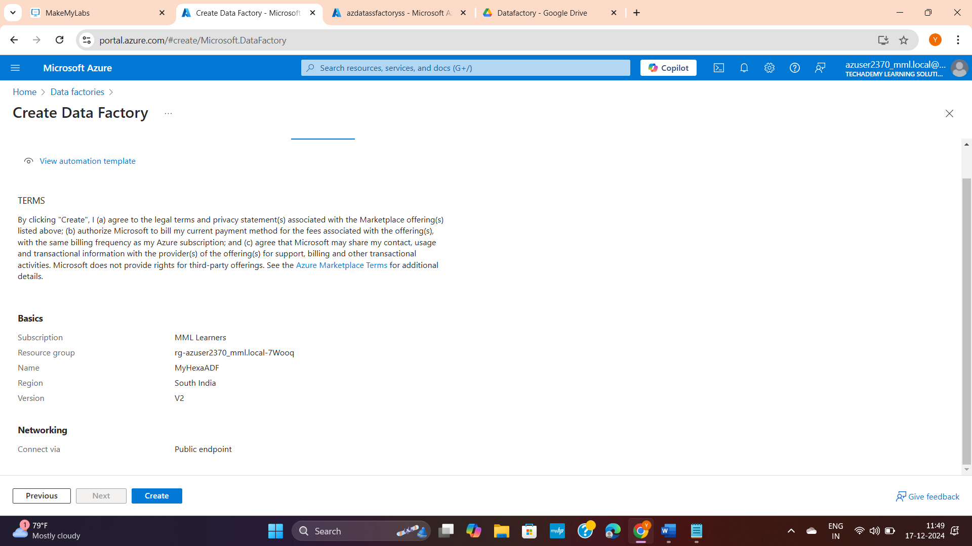

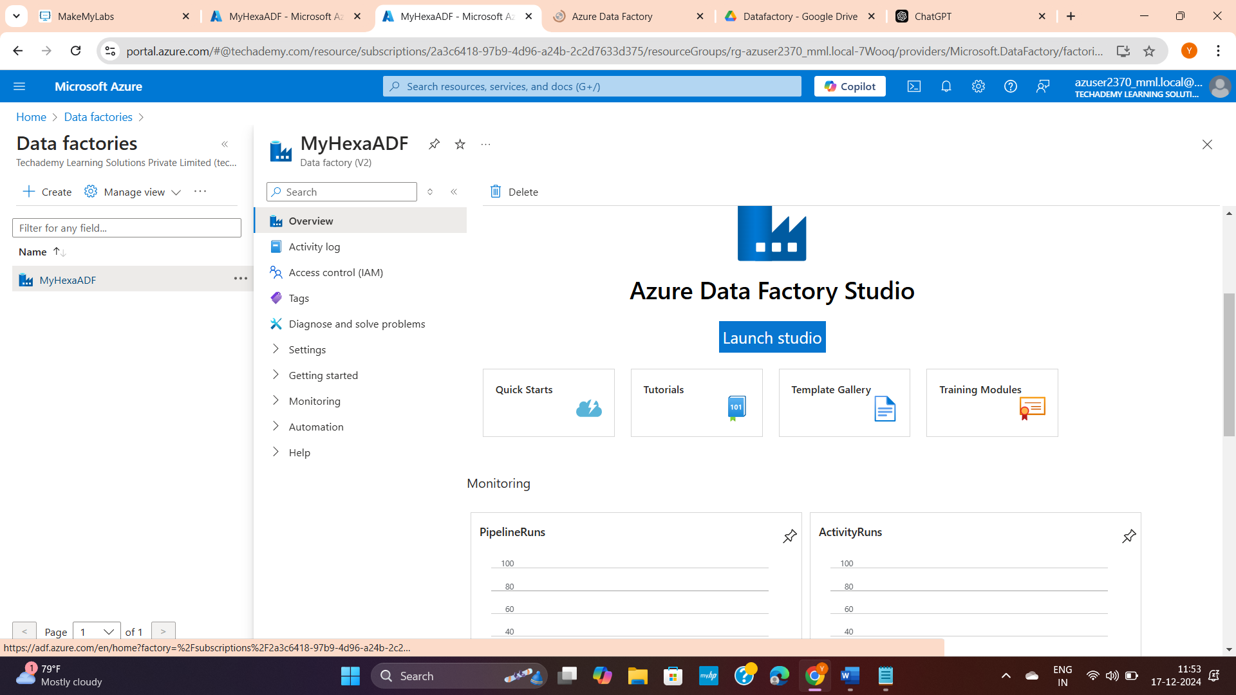

**ADF launch:**

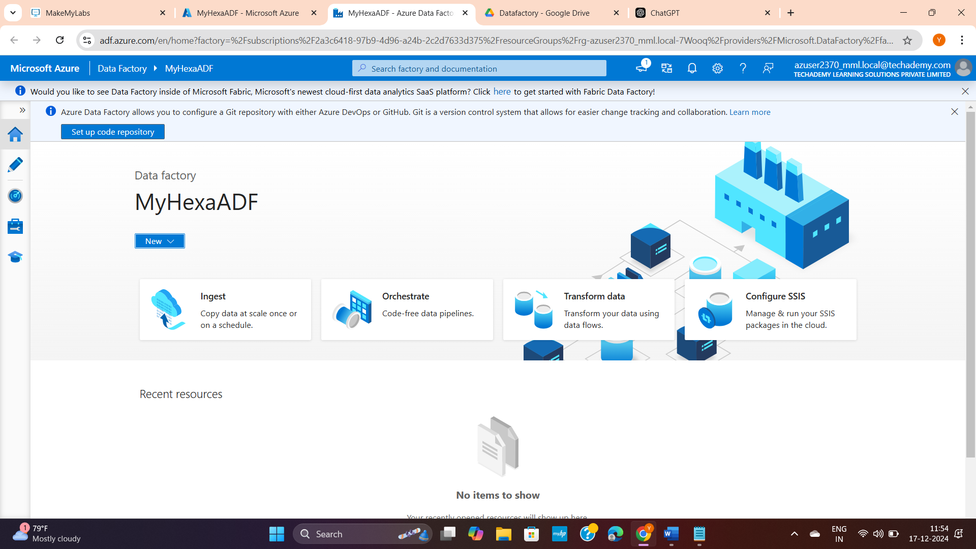

**Pipeline:**

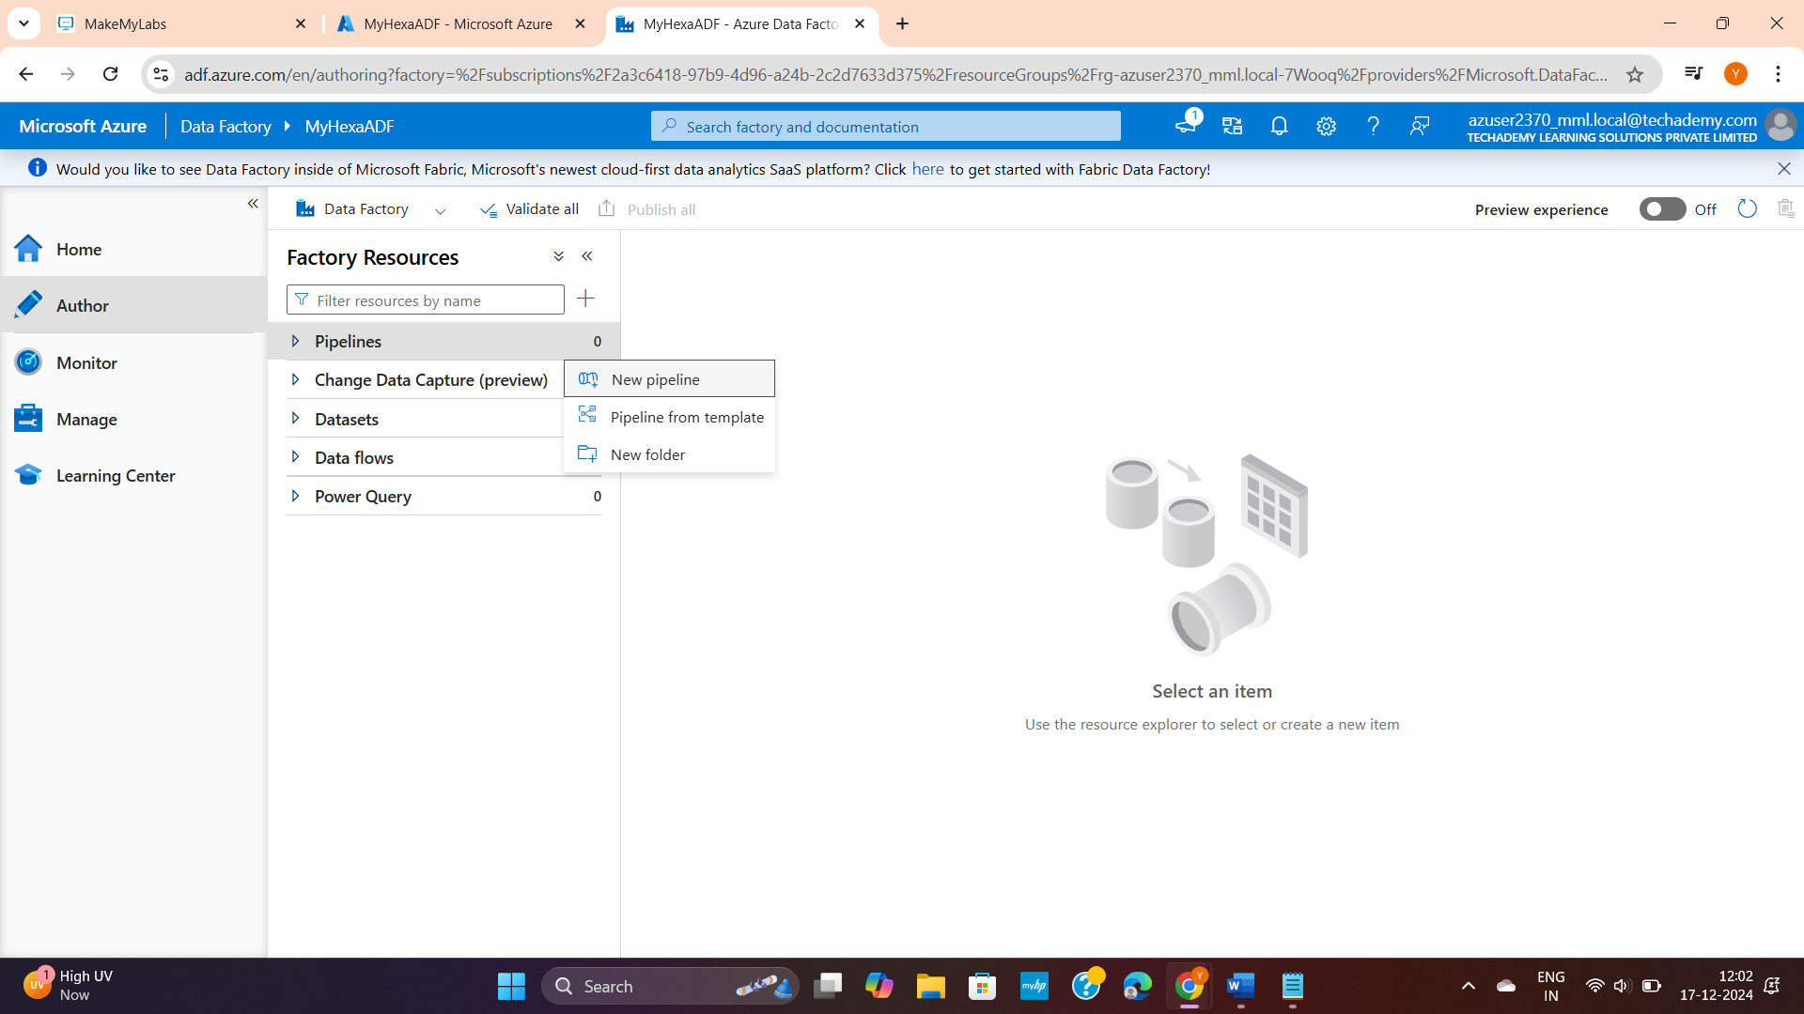

You can drag any thing in the option like I dragged 3 notebooks.

And create your pipeline where:

red – if fails

green – if success

blue line – on completion

(all the above points, you will get in the user friendly page itself)

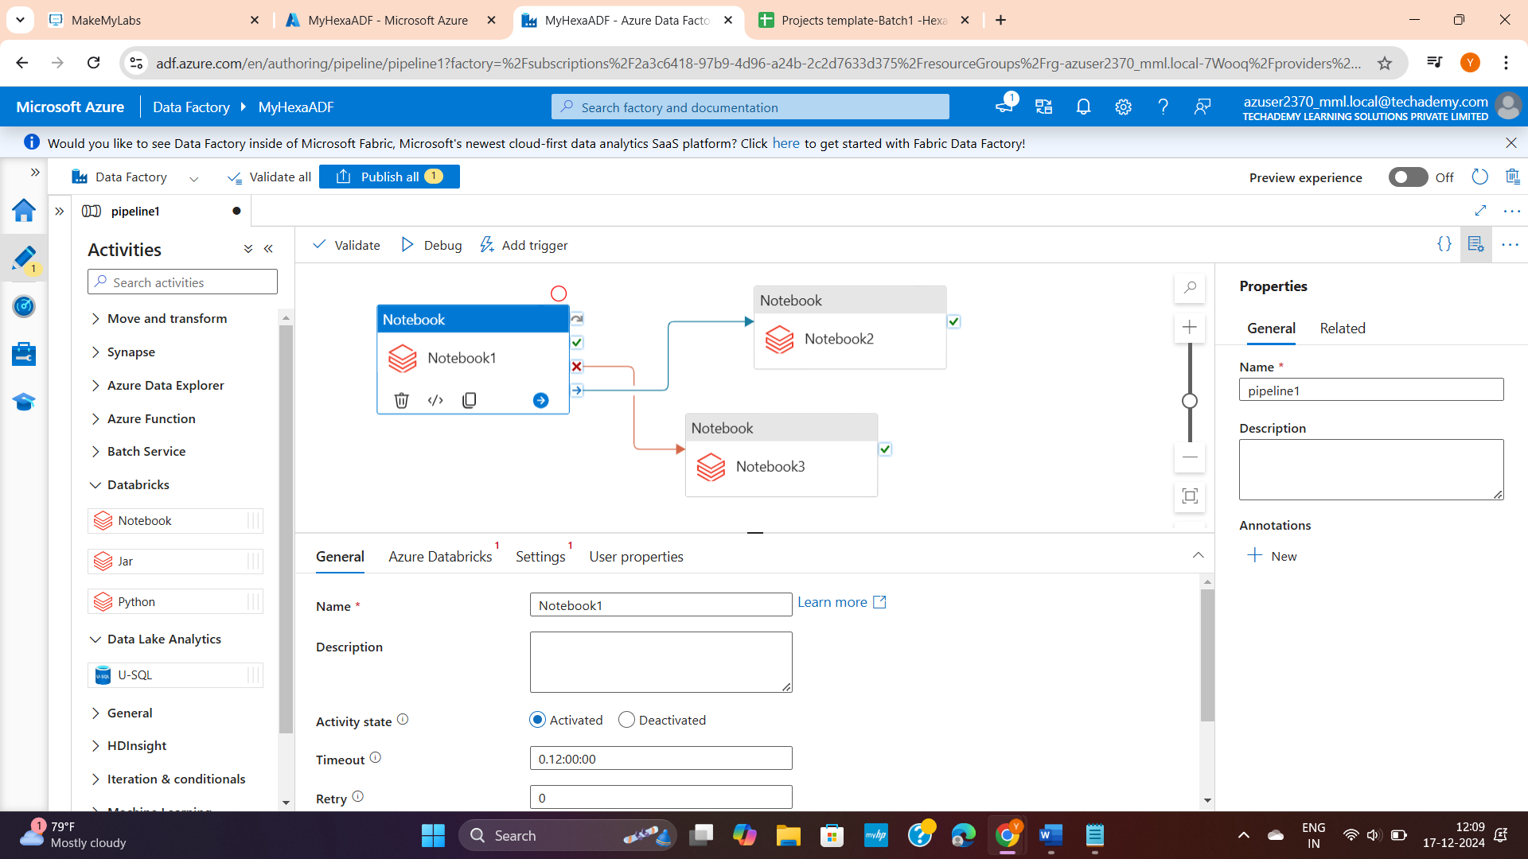

**Linking ADF with other accounts:**

If you want to link your databricks click and link with access tocken

